SCUBA-2 Block Specification
rx_fifo

Table of Contents

1. Block Overview 3
1.1 Block Location and Block Interface Within System 3
1.2 Block Functionality / Features 3
1.3 Block Dataflow 3
2. Block Interfaces 4
2.1 Interface Signal Description 4
2.2 Interface Protocol and Timing 4
3. High-Level Description 5
3.1 Block Description 5
4. Files of the Block 6
4.1 Source Code 6
4.1.1 rx_fifo.vhd 6
4.1.2 sync_fifo_rx.vhd 6
4.2 Header Code 6
4.2.1 compnent_pack.vhd 6

Block Overview

Block Location and Block Interface Within System
This block is located on the clock card FPGA. It interfaces with the following blocks on the clock card:

- rx_control
- rx_protocol_fsm

Block Functionality / Features
- This FIFO block acts as a buffer between incoming data from the Cypress CY7B933 HOTLinkTM receiver and the command protocol parser block ‘rx_protocol_fsm’. Writing to this FIFO is controlled by the rx_control block. The block has been implemented as an asynchronous FIFO, with an asynchronous clear.
- The core of the FIFO is the entity sync_fifo_rx.vhd, which is a synchronous FIFO ‘Megafunction’ created with QUARTUS II.

Block Dataflow

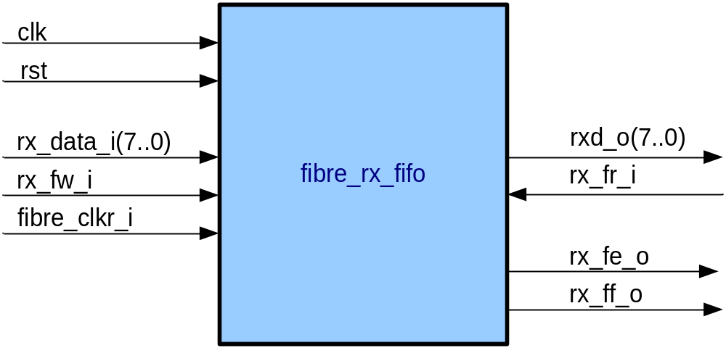

Block Interfaces

Interface Signal Description
- Interface Signals
Signal | Description | Direction
Global Signals
clk_i | Global clock (used as FIFO read clock) | in
rst_i | Asynchronous FIFO reset | in
Control Signals
rx_fw_i | FIFO write enable. When asserted data on rx_data_i is written to the FIFO on next edge of fibre_clkr_i (FIFO write clock). | in
rx_data_i | Byte wide data input to FIFO | in
fibre_clkr_i | Input signal from Hotlink receiver. Used as FIFO write clock. | in
rx_fr_i | FIFO read request. When asserted data from the FIFO is written to rxd_o.
rxd_o | Byte wide data output from FIFO | out
rx_ff_o | FIFO full flag. Indicates to the rx_control block that the FIFO is full and cannot be written to. | out
rx_fe_o | FIFO empty flag. Indicates to the rx_protocol_fsm block that there is no data to read from the FIFO. | out

Interface Protocol and Timing

High-Level Description

Block Description

rx_fifo provides an interface to the QUARTUS Megafunction entity “sync_fifo_rx”.

Files of the Block

Source Code

rx_fifo.vhd
Interface to sync_fifo_rx core.

sync_fifo_rx.vhd
Rtl core of instantiated synchronous FIFO block ‘sync_fifo_rx’ (created with QUARTUS II Megafunction wizard).

Header Code

compnent_pack.vhd
This file contains the ‘sync_fifo_rx’ component declaration.

